Affordable Learning Georgia Textbook Transformation Grants
Final Report
Date: May 23, 2017
Grant Number: 137
Institution Name(s): Kennesaw State University
Team Members (Name, Title, Department, Institutions if different, and email address for each):
Dr. Tamara Powell, Director, College of Humanities and Social Sciences Office of Distance Education, Professor of English, Kennesaw State University—Kennesaw Campus, tpowel25@kennesaw.edu
Dr. Jonathan Arnett, Assistant Professor of English, Kennesaw State University—Kennesaw Campus, earnett@kennesaw.edu
Dr. Cassandra Race, Lecturer, Digital Writing and Media Arts, Kennesaw State University—Marietta Campus, crace@kennesaw.edu
Dr. Monique Logan, Lecturer, Digital Writing and Media Arts, Kennesaw State University—Marietta Campus, mlogan15@kennesaw.edu
Ms. Tiffani Reardon, Instructional Designer, College of Humanities and Social Sciences, Kennesaw State University, treardo2@kennesaw.edu
Ms. Megan MacDonald, Instructional Designer, Distance Learning Center, Kennesaw State University, mmacdon3@kennesaw.edu
Mx. James Monroe, Student Worker, College of Humanities and Social Sciences Office of Distance Education, Kennesaw State University, krm0540@students.kennesaw.edu
Mr. Lance Linimon, Closed Captioner, linimon@me.com
Project Lead: Dr. Tamara Powell
Course Name(s) and Course Numbers:
WRIT 3140: Workplace Writing
TCOM 2110: Technical Communication
Semester Project Began: Fall 2015
Semester(s) of Implementation: Summer 2016, Fall 2016
Average Number of Students Per Course Section: Summer: 22 Fall: 23.5 Spring: 25
Number of Course Sections Affected by Implementation: Summer 2016: 2; Fall 2016: 11; Spring 2017: 10
Total Number of Students Affected by Implementation: 496

1. Narrative
A. Describe the key outcomes, whether positive, negative, or interesting, of your project.

The transformation experience was exhilarating and inspiring as we achieved our dream of creating a resource for students that was under our control and reflected the way we wanted to teach. It was also challenging—we learned that remixing materials is complicated and time consuming. As human beings, we had human problems get in the way of our project, which caused delays. And that meant we were up against the clock in the last weeks before the pilot.
We found that getting SMEs to create video lectures or schedule filming sessions was harder and more time-consuming than we had anticipated. In spite of being offered $50 honorariums, several of the experts we originally approached backed out at the last minute, and other experts found it difficult to schedule time to record their videos.

Another content-creation problem we encountered was the issue of authorial voice. Six separate authors worked on the book’s chapters and examples, and the final product clearly reflects this division of labor. We somewhat finessed a solution by treating the book as almost an anthology: new chapters bear the name of the group member who created them; transformed chapters that required light editing bear the original authors’ names; and transformed chapters that required extensive editing bear both the editors’ and the original authors’ names.

By far, the most problematic issues that the group members faced appeared while attempting to integrate the McMurrey text’s chapters; rather than being able to edit the existing chapters on a surface level, group members often found themselves rewriting the chapters to solve problems with theory, verbosity, and focus. One example of theoretical problems appeared in a chapter that discussed a technical communicator’s need to “translate” concepts for a document’s audience. In context, the idea of translating ideas from engineering-ese into English makes intuitive sense, but technical communicators prefer to “articulate” concepts so they are appropriate for a target audience [1].

Similarly, the original McMurrey chapters were written in a conversational style, but a major target audience for our OER is engineering and computer science majors, who greatly prefer short, concise documents. Furthermore, the original chapters contained many long paragraphs with multiple sentences, but research indicates that short paragraphs with short, pithy sentences are more readable online—especially on smaller screens—[2], which is how we anticipate our students will access the textbook.

Problems with focus appeared with in-text examples and sample documents that focused almost exclusively on engineering. While many of our students are engineers-in-training, many of our students are computer science majors, and a smaller but significant minority are Integrative Studies majors, whose degrees combine multiple academic areas; examples that exclusively catered to engineers would not benefit either cohort of students. Also, if we wish to expand this OER and extend it to other technical communication or business writing courses, we need to take care not to alienate these other potential readers.

Overall, it was a good experience for us, and a good experience for our students. Thank you to the USG and Affordable Learning Georgia for helping to make this dream of ours a reality.

[1] J. D. Slack et al. “The technical communicator as author: Meaning, power, authority,” J. Bus. Tech. Comm, vol. 7, no. 1, pp. 12-36, Jan. 1993.

[2] J. Nielsen and J. Morkes. (1998, Jan. 6). Applying writing guidelines to web pages [Online]. Available: https://www.nngroup.com/articles/applying-writing-guidelines-web-pages/

3. Quantitative and Qualitative Measures
3a. Overall Measurements
Student Opinion of Materials
Was the overall student opinion about the materials used in the course positive, neutral, or negative?
Total number of students affected in this project: for summer 2016, 36
- Positive: 95 % of 21 respondents
- Neutral: 0 % of 21 respondents
- Negative: 5 % of 21 respondents

Student Learning Outcomes and Grades
Was the overall comparative impact on student performance in terms of learning outcomes and grades in the semester(s) of implementation over previous semesters positive, neutral, or negative?

Choose One:
- X--online Positive: Higher performance outcomes measured over previous semester(s)
- ___ Neutral: Same performance outcomes over previous semester(s)
- X—face to face Negative: Lower performance outcomes over previous semester(s)
In the online course, the average grade rose from 74 to 78% (C). In the face to face course, the average grade dropped from 84.38 to 80.42 (B).
Student Drop/Fail/Withdraw (DFW) Rates
Was the overall comparative impact on Drop/Fail/Withdraw (DFW) rates in the semester(s) of implementation over previous semesters positive, neutral, or negative?
Drop/Fail/Withdraw Rate:
For summer 2016
6% of students, out of a total 16 students affected, dropped/failed/withdrew from the face to face course in the first semester of implementation.
16% of students, out of a total 25 students affected, dropped/failed/withdrew from the online course in the first semester of implementation.
Choose One:
- X—face to face Positive: This is a lower percentage of students with D/F/W than previous semester(s)
- ___ Neutral: This is the same percentage of students with D/F/W than previous semester(s)
- X--online Negative: This is a higher percentage of students with D/F/W than previous semester(s)
3b. Narrative
Here are the statistics from the two pilot courses, one online and one face to face (SUMMER 2016). We also included numbers from the same courses offered the previous summer with publisher materials (SUMMER 2015). Please note, Kennesaw State University and Southern Polytechnic State University consolidated in 2015. This course was originally WRIT 3140: Introduction to Technical Communication in 2015. In 2016, it became WRIT 3140: Workplace Writing. The main student audience shifted from computer science majors to integrative studies majors. For this reason, comparing the data from summer 2015 and summer 2016 has been a bit like comparing apples and oranges.
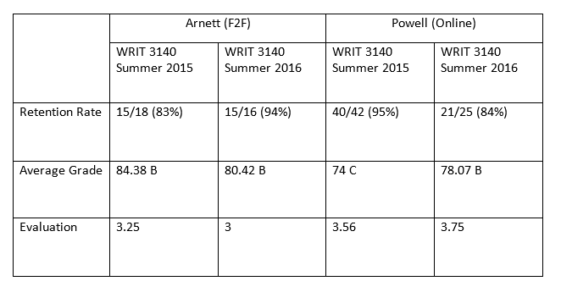

While students had mixed feelings about the textbook, stating in course evaluations that
“I did not like the set up of the course textbook. It was just okay.”
and
“Maybe more videos and handouts and a printed book to supplement or in primary use of the content.”
Students were also provided the opportunity to respond to a survey solely about the textbook.
What follows is a summary of the questions and responses from the 21 students who responded, out of 36 total students in the two sections.
Of the respondents, 15 were in the online section, and 5 were in the face to face section, and one declined to answer the question.
Nineteen students said they acquired the textbook without trouble, and two said they had no trouble acquiring it, but they didn’t acquire it because they didn’t want it.
When asked, “Did you feel the organization of the textbook was complementary to the course organization?” 18 answered “yes,” and three answered, “no.”
When asked, “Do you feel there were any gaps in the textbook as far as course content goes?” 19 answered “no,” and two answered, “yes.” Students were asked to comment on any gaps observed, but none did.
Students were asked, “Did the textbook for this class help you with coursework?” The responses provided, below.
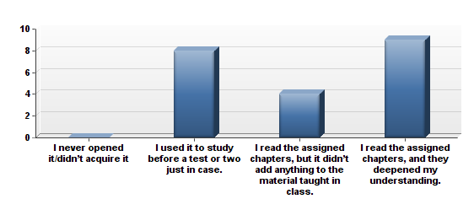

When asked, “Were the example documents provided in the textbook helpful to you as you learned the material?” 8 students answered, “Very helpful,” and 12 students answered, “Somewhat helpful.” No students selected “Not helpful.” One student selected, “Don’t know/couldn’t say.”
As we created the textbook, we were particularly proud of the videos, quizzes, activities, sample documents, and other materials that we created to support learning and engagement in the online textbook. When asked, “Were the supplemental materials in the textbook (videos, quizzes, activities, sample documents) helpful to you as you used the textbook to learn the material?” 12 students responded, “The supplemental materials were somewhat helpful,” and 9 students answered, “The supplemental materials were very helpful.” Three other choices, “There were no supplemental materials in my textbook,” “The supplemental materials were not helpful,” and “The supplemental materials were very helpful” were not selected.

When asked, “Think about the supplemental materials in the textbook (videos, quizzes, activities, sample documents). Which of these (videos by experts in the field or professors, practice quizzes on concepts presented in the text, activities to assist you in learning more about the material or exploring the material in depth, sample documents) helped you to learn more about the topic of technical writing/workplace writing?” students answered as follows, showing a preference for the sample documents.

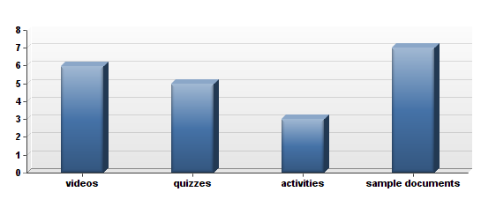
When asked, “Compare this to other textbooks (not including non-textbook assigned reading),” students responded as follows:
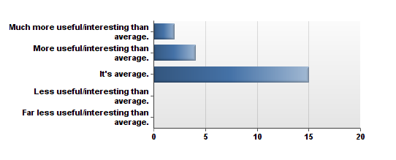

When asked, “How useful do you think this textbook will be after class is over?” students responded as follows:
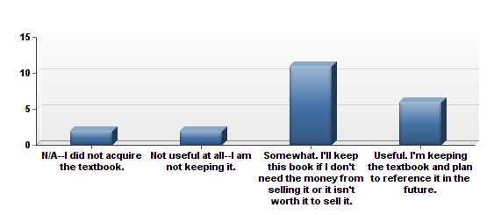

When asked, “How much did cost affect your decision on whether or not to buy and read the book?”
No students answered that they could not afford the open educational resource we had created. This answer changed from 2015 when publisher materials were in use, and 15% of respondents then said “Very much. I could not afford it, so I didn’t buy/read it.”
There were other interesting findings from the survey. Five of the 20 students responding to a question about use of the textbook shared that they printed out at least some of it. Two of the 20 students shared that they sometimes used the screen reader to listen to the ebook instead of read it with their eyes.

When asked, “Thinking about the textbook required for the course, which of the following statements do you feel is most accurate about your experience?” The students responded as follows:
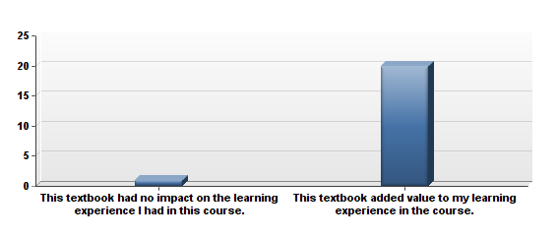

One interesting response emerged from a question regarding how a student decides if he or she acquires the book for a course. One student answered, “I never acquire a textbook, no matter what.” Presumably, even though a free textbook was provided, the student declined to use it.
Students were also asked to provide any additional feedback they wishes (these responses are shared in their entirety under “Quotes,” below.) From the student responses, we realized that perhaps in addition to a video assisting students in navigating the D2L site, we should also create a video to assist them in navigating the online textbook. Also, we want to continue to add examples, videos, activities, and sample documents to the textbook as we continue to update it each year.
In comparing the survey data from summer 2015, when publisher textbooks were used, to the survey data from 2016 when the OER was used, some interesting findings presented themselves.
In 2015, 2/26 students said that they were unable to afford the textbook, vs. 0/21 in 2016.
When asked, “Did you feel the organization of the textbook was complementary to the course organization,” 95% said “yes” in 2015. 85.71% said “yes” in 2016, indicating that the new courses need to be looked at carefully to ensure they are aligned with the textbook when appropriate.
When asked, “Do you feel there were any gaps in the textbook as far as course content goes,” 0% said yes in 2015 vs. 9.52% who answered “yes” in 2016. Students were asked to supply details in a space below the question, but none did. However, in the course evaluations, one student requested that instructions and standard operating procedures be added to the course, and the instructors have discussed adding those materials as soon as possible to WRIT 3140.
When asked, “Did the textbook for this class help you with coursework,” in 2015, 19.25% said they never opened it vs. 0% who responded that way in 2016. In 2015, 50% of the students said they read the assigned chapters and it deepened their understanding vs. 42.86% who answered the same way in 2016.
When asked, “Were the supplemental materials in the textbook (videos, quizzes, activities, sample documents) helpful to you as you used the textbook to learn the material,” 26.92% said “yes” in 2015 vs. 42.86% in 2016. And it’s true, we are very proud of the supplementary materials the subject matter experts and instructional designers placed in the course.
In 2016, 80% of students said they acquired the book without stress, compared to 65.38% in 2015.
Finally, when asked to choose between two statements, 1) This textbook had no impact on the learning experience I had in this course vs. 2) This textbook added value to my learning experience in the course, 73.08% selected #2 in 2015 compared to 95.24% who selected #2 in 2016. Both surveys are included in this final report.

2. Quotes
At the end of the survey, student were asked for any feedback they wished to share. Here are the 12 responses that were provided.
This textbook was easy to understand and move through the course. The only thing I did not like was there were not very many visuals and examples.
it was so helpful
I love that the text book was given to the course instead of having to purchase the book. The material was useful but was difficult to see all of it because of the way it was organized.
The textbook was helpful, but not as helpful as other textbooks. I wish it was better description and examples provided for each section.
This class was very interesting especially since it is my last semester. [The professor] is a great instructor and cares about [the] students. However, it took some time getting use to the course material and the modules. The information I grasp I will continue to apply it in my everyday life.
The textbook was helpful in guiding me through the assignments. The activities were the most helpful out of all the supplemental materials for the class.
I felt that this book was perfectly integrated with the course material and assignments. It definitely helped me on all assignments and quizzes as well as have me a better understanding of the material we covered.
I am glad I did not have to pay for the book because it allowed me to save money. I found the book easy to access. The book works well with the course.
I feel this course is full of useful information regarding technical/workplace writing. I am not 100% sure if it is the course material or the layout of the online book but at times it got confusing to follow. It did not always flow very well, but that could be do to the material at hand and not necessarily because of the book.
I liked how the book was provided to the class. It was also very helpful to have the extra clarification in understandable terms so that I could understand all the concepts.
having the online readings allowed it useful and affordable to educate and increase my knowledge for my class.
The survey that this online course just had to take wasn't fully relevant to us considering that we didn't have to buy the textbook at all because it was provided to us in our modules. This made answering some of these questions a bit difficult. The book is well written and very informative on the topics at hand. For me personally if each module could be set up where there is one page rather than multiple pages it would be less overwhelming for each week. But other than that, the textbook is very well laid out and written.

Additional data:

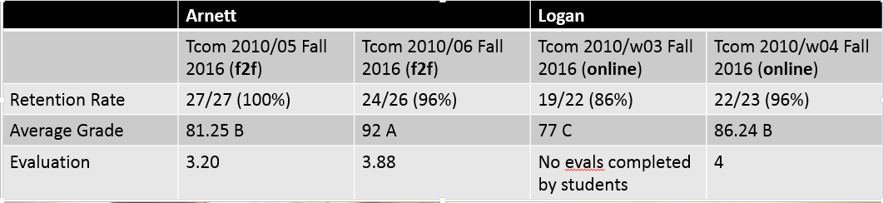

4. Sustainability Plan
The materials are freely available to anyone on the internet. Each year we will discuss revisions. We also plan to add videos and sample documents to enhance the usefulness of the offerings. We will meet and discuss revisions each year. In the survey, some students indicated that they did not feel the course organization was complementary to the textbook. We will examine the course revisions to ensure that they are aligned more closely with the textbook when appropriate. Also, as noted in the narrative, for WRIT 3140, the student audience changed from information science majors in 2015 to integrative studies (leadership studies) majors in 2016. (For the TCOM 2010 offerings, the audience will remain engineering majors and information science majors.) In 2016, 2 students indicated that they felt there were gaps in the textbook as far as course content was concerned. While these two respondents declined to provide details, in the course evaluations, students requested that writing instructions and standard operating procedures be added to the course. This information is included in the new textbook but was not assigned in the 2016 online course. From reviewing this student feedback, it seems that writing instructions and standard operating procedures readings and assignments need to be added to the 2017 online WRIT 3140 course.

5. Future Plans
From Jonathan Arnett:
I'd like to continue revising the book, as I'm not thrilled with its current state. I have asked Tiffani Reardon to install analytics and track how students are using/not using the book; a few presentations and at least one publication (likely IEEE) could come out of that, for sure.

From Cassandra Race:
I've come to a more powerful recognition of just how important it is to tailor our materials to our student population, and I've learned that I am really, really picky about what I use! I also like creating my own materials and lessons, and just using the text as a reference or foundation. That allows me the flexibility to have a text as support while tailoring instruction to needs of the students, for example the engineering students writing the proposals for capstones and so forth.

From Monique Logan:
Thus far, I along with members of this book project as well as those of my department plan to present Sexy Technical Communication at the ProComm 2016 conference in Austin, TX on October 3-5, 2016.

From Tamara Powell
I have been asked to create an African American literature course, and after this project, I have designed the new course to use OERs completely.

6. Description of Photograph
Left to right, Dr. Cassandra Race, Subject Matter Expert; Dr. Monique Logan, Subject Matter Expert; Dr. Jonathan Arnett, Subject Matter Expert, Ms. Tiffani Reardon, Instructional Designer; Dr. Tamara Powell, Team Lead and Subject Matter Expert.

