Affordable Learning Georgia Textbook Transformation Grants
Final Report
To submit your Final Report, go to the Final Report submission page on the ALG website: http://affordablelearninggeorgia.org/site/final_report_submission
Final report submission requires four files:
- This completed narrative document
- Syllabus or syllabi
  - (if multiple files, compress into one .zip folder)
- Qualitative/Quantitative Measures data files
  - (if multiple files, compress into one .zip folder)
- Photo of your team or a class of your students w/ at least one team member, minimum resolution 800x600px
  - (nearly all smartphones take photos larger than this size by default)
Follow the instructions on the webpage for uploading your documents. Based on receipt of this report, ALG will process the final payment for your grant. ALG will follow up in the future with post-project grantee surveys and may also request your participation in a publication, presentation, or other event.

General Information
Date:06.01.2018
Grant Round:10
Grant Number:337
Institution Name(s): Albany State university
Project Lead: Liqiu Zheng
- Team Members Dr. Liqiu Zheng, Associate Professor of Physics, Department of Natural & Forensic Sciences, Albany State University. Email – liqiu.zheng@asurams.edu
- Dr. Arun K Saha, Associate Professor of Physics, Department of Natural & Forensic Sciences, Albany State University. Email – arun.saha@asurams.edu
Course Name(s) and Course Numbers: Physical Science II/Phys1012
Semester Project Began: Fall 2017
Semester of Implementation: Spring 2018
Total Number of Students Affected During Project: 23

1. Narrative
The goal was to improve the overall physical science education quality; to boost the passing rate and decrease the withdraw rate for physical science learning; and eventually to enhance the retention rate campus-wide by adopting low cost and readily accessible electronic teaching/learning textbook (eBook) in GeorgiaView and university repository. Without buying a costly textbook, students performed lots of learning activities at a one-stop learning environment to ensure their science learning outcomes. Various best-illustrated topics of physical science course were excerpted from different textbooks and placed in GeorgiaView and university repository. Meanwhile, as one unique science class, virtually all physical science concepts relate to the things in our daily life. In order to better grasp them, YouTube online demonstration were linked to GeorgiaView and university repository to further enhance the learning outcome because it would accommodate different learning needs like Visual and Auditory learners. Additionally, problems and exercises to facilitate understanding/applying each and every concept, which were stated in different styles, were embedded in the learning materials to suit the learners from different backgrounds. All of developed materials are posted/stored in the following URL for open access to everyone -http://hdl.handle.net/10675.1/620195

A. Describe the key outcomes, whether positive, negative, or interesting, of your project. Include:
- Summary of your transformation experience, including challenges and accomplishments
1. Students had more multiple resources to boost their learning with zero cost
2. The teaching materials cover a wide range of physical science to cater for students with different backgrounds.
3. Students enjoyed the exposure to various reading materials and exercises materials.
4. The implementation time frame is too short-only one semester. The longer time implementing it, the more students would get impacted.
- Transformative impacts on your instruction
This allows for the flexibility, more effective of teaching.
- Transformative impacts on your students and their performance
Students demonstrate more passionate for learning science.
B. Describe lessons learned, including any things you would do differently next time.

2. Quotes
- Provide three quotes from students evaluating their experience with the no-cost learning materials.
- Blanding, Lezilee D
“I really appreciated the free material offered to us, I feel as if it was helpful b/c sometimes students in college don’t have jobs and school checks don’t come until months after school had already began. Having the course material offered to us online w/ free access 24/7 was very convenient”
- Cole Sutton
“New material was helpful and should be used in future”

Meanwhile, the following survey questions were asked for the participating students to measure the effectiveness of the course material developed.

Date: April 24, 2018
Survey Questionnaires & Responses
Free Text Book
Course Name: Physical Science II (PHSC 1012)
Spring 2018
The following questions are related to Text Book material developed for you which is at FREE of cost.
1. How do you like the content of this book?
- Liked very much 61.5% (b) Liked somewhat (c) Did not like 38.5%

- Do you think that this FREE book will help you secure a better grade?
- YES 92.3% (b) NO 7.7%

- How accessible is the FREE material?
- Very much accessible 69.2% (b) Somewhat accessible 15.4% (c) Not accessible at all 15.4%

- Do you think that for this FREE Text Book, you will be able to focus more on your study rather than spending more time in outside employment to earn money for Text Book?
- YES 100% (b) NO 0%

- Next semester, ASU will offer two sections of this course. One section will adopt regular hard cover Text Book (which you are using now) and other section will adopt the FREE Text Book. Which section will you recommend your friend to get enrolled in?
- Section adopting FREE Text Book 92.3% (b) Section adopting hard-cover printed Text Book 7.7%

3. Quantitative and Qualitative Measures

3a. Uniform Measurements Questions
The following are uniform questions asked to all grant teams. Please answer these to the best of your knowledge.
Student Opinion of Materials
Was the overall student opinion about the materials used in the course positive, neutral, or negative?
Total number of students affected in this project: ___23_______
- Positive: ___78.5____ % of ___13_____ number of respondents
- Neutral: _______ % of ________ number of respondents
- Negative: __21.5_____ % of __13_____ number of respondents

The following 10 survey questions are asked to the students to get student opinion about the current Text Book.
Date: April 24, 2018
Survey Questionnaires & Responses
Free Text Book
Course Name: Physical Science II (PHSC 1012)
Spring 2018

Question from 1-10 is related to your current costly Text Book with hard cover.

- Did you have the text book on First Day of semester?
(a) YES 7.7% (b) NO 92.3%
2. For your PHSC 1012 course, did you buy the Text Book?
- YES 15.4% (b) NO 84.6%

3. When did you buy?
- Beginning of semester 7.7% (b) After midterm 15.4% (c) Not yet 76.9%

4. Did you wait for refund check to buy this Physics text book?
- YES 23% (b) NO 77%

5. Do you think that the cost of your text book for PHSC 1012 was affordable?
- YES 23% (b) NO 77%

- How do you rate your affordability in buying this text book?
- Very much affordable 23% (b) Somewhat affordable 54% (c) Not affordable 23%

- How did you like the content of the book?
- Liked very much 15.4% (b) Liked somewhat 76.9% (c) Did not like 7.7%

- How did you like the presentation of the content?
- Liked very much 46.1% (b) Liked somewhat 46.2% (c) Did not like 7.7%

- Were the interactive video links in the text book helpful for you?
- Very much helpful 23% (b) Somewhat helpful 38.5% (c) Not helpful 38.5%

- Do you think that, due to the high cost of your text book, you had to engage in outside employment for longer period of time and found less time for study??
- YES 46.2% (b) NO 53.8%

Student Learning Outcomes and Grades
Was the overall comparative impact on student performance in terms of learning outcomes and grades in the semester(s) of implementation over previous semesters positive, neutral, or negative?
Student outcomes should be described in detail in Section 3b.

Choose One:
- ___ Positive: Higher performance outcomes measured over previous semester(s)
- _X__ Neutral: Same performance outcomes over previous semester(s)
- ___ Negative: Lower performance outcomes over previous semester(s)
Student Drop/Fail/Withdraw (DFW) Rates
Was the overall comparative impact on Drop/Fail/Withdraw (DFW) rates in the semester(s) of implementation over previous semesters positive, neutral, or negative?
Drop/Fail/Withdraw Rate:
Depending on what you and your institution can measure, this may also be known as a drop/failure rate or a withdraw/failure rate.
__17.4_____% of students, out of a total __23_____ students affected, dropped/failed/withdrew from the course in the final semester of implementation.
Choose One:
- ___ Positive: This is a lower percentage of students with D/F/W than previous semester(s)
- ___ Neutral: This is the same percentage of students with D/F/W than previous semester(s)
- _X__ Negative: This is a higher percentage of students with D/F/W than previous semester(s)

3b. Measures Narrative
In this section, summarize the supporting impact data that you are submitting, including all quantitative and qualitative measures of impact on student success and experience. Include all measures as described in your proposal, along with any measures developed after the proposal submission.
[When submitting your final report, as noted above, you will also need to provide the separate file (or .zip with multiple files) of supporting data on the impact of your Textbook Transformation, such as surveys, analyzed data collected, etc.]
- Include measures such as:
  - Drop, fail, withdraw (DFW) delta rates
  - Course retention and completion rates
  - Average GPA
  - Pre-and post-transformation DFW comparison
  - Student success in learning objectives
  - Surveys, interviews, and other qualitative measures
- Indicate any co-factors that might have influenced the outcomes.

We focused on GPA and DFW comparison to measure the effectiveness of this project. For the fairness, we provided data taken only from one instructor Dr. Arun Saha’s (Co-PI) grade distribution form since the PI was not assigned physical science II in spring 2018. The result shows that DFW rate slightly increased when compared with that of two previous semesters as shown in Figure 1. But there is no any significant change in average GPA of the class as shown in Fig.2
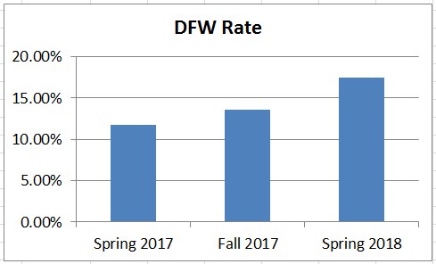

Figure 1. DFW rate of Physical Science II course for 3 consecutive semesters

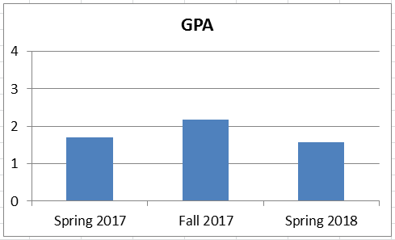

Figure 2. Average GPA of Physical Science II Course in three consecutive semesters

Factors Affecting Outcomes
Recently, we observe that the number of students NOT coming to class is increasing day by day. First couple of days they come to school and then contact instructor at the end of semester to inform their situations which prevented them from attending the school. It does not matter to those students whether Text Book is free or not. A screen shot of one student’s such email is provided below -
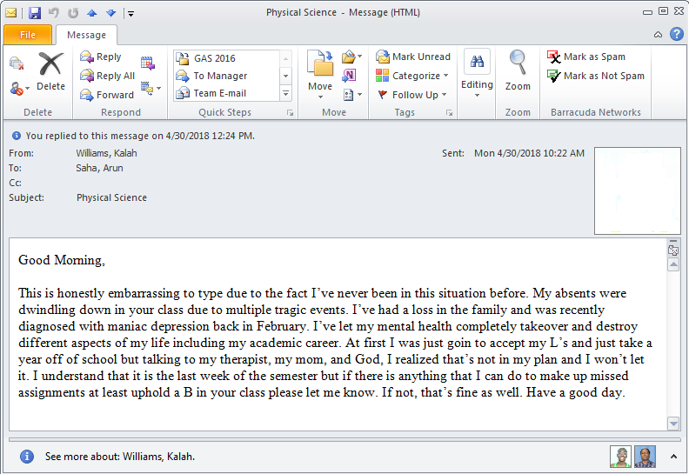

4. Sustainability Plan
- Describe how your project team or department will offer the materials in the course(s) in the future, including the maintenance and updating of course materials.

Physical Science courses are offered from the College of Science and Technology and in this college all instructors teaching Physical Science course are advised by Department Chair to use same course materials. As the developed material is posted in GeorgiaView, so it can easily be copied or transferred to any instructor’s portal.

5. Future Plans
- Describe any impacts or influences this project has had on your thinking about or selection of learning materials in this and other courses that you will teach in the future.
- Describe any planned or actual papers, presentations, publications, or other professional activities that you expect to produce that reflect your work on this project.

We plan to present our project outcome in AAPT (Association of American Physics Teachers) or Georgia Academy of Science Annual meeting in 2019.

6. Description of Photograph
- On the Final Report Submission page, you will be submitting a photo. In this document, list the names of the people shown in this separately uploaded photograph, along with their roles.
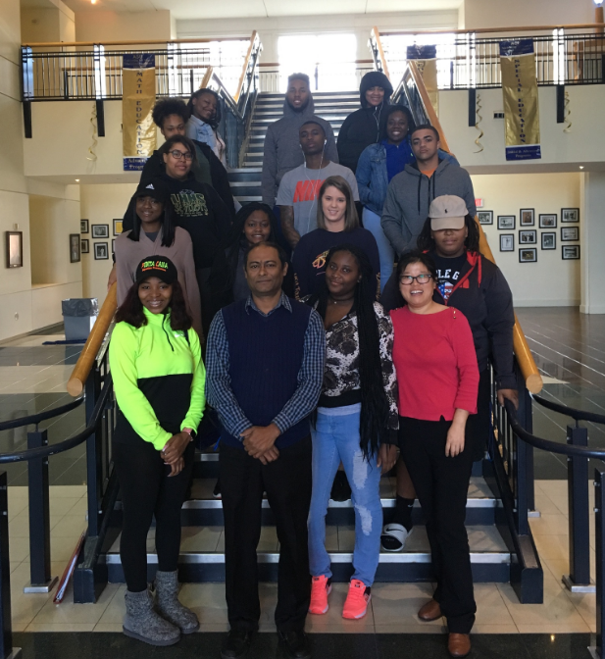

First row #1 from right: Dr. Liqiu Zheng – PI
First row #3 from right – Dr. Arun Saha – Co-PI

