Grants Collection
Kennesaw State University
UNIVERSITY SYSTEM OF GEORGIA

Tamara Powell, Jonathan Arnett, Cassandra Race, Monique Logan, Tiffani Reardon, Megan MacDonald, James Monroe, Lance Linimon

Technical Communication

Grants Collection

Affordable Learning Georgia Grants Collections are intended to provide faculty with the frameworks to quickly implement or revise the same materials as a Textbook Transformation Grants team, along with the aims and lessons learned from project teams during the implementation process.

Each collection contains the following materials:

- Linked Syllabus
  - The syllabus should provide the framework for both direct implementation of the grant team’s selected and created materials and the adaptation/transformation of these materials.
- Initial Proposal
  - The initial proposal describes the grant project’s aims in detail.
- Final Report
  - The final report describes the outcomes of the project and any lessons learned.

Unless otherwise indicated, all Grants Collection materials are licensed under a Creative Commons Attribution 4.0 International License.

Initial Proposal

Application Details Manage Application: Textbook Transformation Grant
Award Cycle: Round 3

Internal Submission
Deadline:
Sunday, May 31, 2015

Application Title: 137 Submitter First Name: Tamara Submitter Last Name: Powell

Submitter Title: Dr.
Submitter Email Address: tpowel25@kennesaw.edu
Submitter Phone Number: 470-578-2911
Submitter Campus Role: Proposal Investigator (Primary or additional)
Applicant First Name: Tamara
Applicant Last Name: Powell
Co-Applicant Name(s): Jonathan Arnett, Monique Logan, Cassandra
Race
Applicant Email Address: tpowel25@kennesaw.edu
Applicant Phone Number: (470)578-2911
Primary Appointment Title: Director, Kennesaw State University College
of Humanities and Social Sciences Office of Distance Education and Associate Professor of English
Institution Name(s): Kennesaw State University--Kennesaw
Campus

Team Members (Name, Title, Department, Institutions if different, and email address for each):
Dr. Tamara Powell, Director, Kennesaw State University College of Humanities and Social Sciences Office of Distance Education and Associate Professor of English, Kennesaw State University, tpowel25@kennesaw.edu;

Dr. Jonathan Arnett, Assistant Professor of English, English Department, Kennesaw State University—Kennesaw Campus, earnett@kennesaw.edu

Dr. Monique Logan, Lecturer, Digital Writing and Media Arts Department, Kennesaw State University—Marietta Campus, mlogan15@kennesaw.edu

Dr. Cassandra Race, Lecturer, Digital Writing and Media Arts Department, Kennesaw State

    - of 22

University—Marietta Campus, crace@kennesaw.edu

Ms. Tiffani Reardon, Instructional Designer, College of Humanities and Social Sciences, Kennesaw State University, treardo2@kennesaw.edu

Mr. Lance Linimon, Closed Captioner, linimon@me.com

Mr. James Monroe, Student Worker, College of Humanities and Social Sciences Office of Distance Education, Kennesaw State University, krm0540@students.kennesaw.edu

Sponsor (Name, Title, Department, Institution):

Dr. Laura Palmer, Chair, Digital Writing and Media Arts (DWMA) Department, Kennesaw State University, Marietta Campus

Dr. H. William Rice, Chair, English Department, Kennesaw State University, Kennesaw Campus

Proposal Title: 137
Course Names, Course Numbers and Semesters Offered:
TCOM 2010: Technical Writing; WRIT 3140: Introduction to Technical Writing (soon to be Workplace Writing). These courses are/will be offered every semester into the foreseeable future.

Final Semester of
Instruction:
Average Number of Students per Course
Section:
Number of Course Sections Affected by Implementation in Academic Year:
Total Number of Students Affected by Implementation
in Academic Year:

Spring 2017

20-50 (generally 27)

21

525

    - of 22

List the original course materials for students (including title, whether optional or required, & cost
for each item):
For Logan, Powell, and Race’s courses: Markel, Technical Communication, required,
$115.99
For Arnett’s courses:
Graves and Graves, A Strategic Guide to Technical Communication, required, $49.95

Proposal Categories: No-Cost-to-Students Learning Materials

Requested Amount of
Funding:
$30,000

Original per Student Cost: For Logan, Powell, and Race's course:
$115.99; for Arnett's course: $49.95

Post-Proposal Projected
Student Cost:
Projected Per Student
Savings:
$0

$115.99 for Logan Powell and Race's course; $49.95 for Arnett's course

Plan for Hosting Materials: Other
Project Goals:
The proposed project involves transforming two currently existing electronic texts into a free, high-quality, interactive, multimedia textbook for the TCOM 2010 and WRIT 3140 courses at Kennesaw State University.

In order to achieve this overarching goal, we intend to:

-create a textbook that satisfies both student and faculty requirements

-develop and incorporate materials that make the textbook desirable for both students and faculty members

-provide material that serves the distinct focus of each course

-make the textbook readily available for adoption and use

-encourage the textbook’s adoption and use in onsite, hybrid, and online versions of the courses

-and as a result, we believe we can increase student retention, progression, graduation, and employment rates.

Per student, we will save $115.99 for Logan, Powell, and Race’s courses and $49.95 for Arnett’s courses.

    - of 22

Total yearly savings for students in Logan, Powell, and Race’s courses, estimating 445 students per year, is $51,615.55.

Total yearly savings for students in Arnett’s courses, estimating 80 students per year, is
$3996.00.

Total savings per year estimate is $55,611.55.

Statement of Transformation:
This project will combine and transform an online technical writing textbook called Online Technical Writing by Dr. David McMurrey (https://www.prismnet.com/~hcexres/textbook/acctoc.html) and two sections of an ebook entitled Why Brilliant People Believe Nonsense by Mr. Steve Miller (ebook, not yet published) and into a new, online textbook. This new textbook will be used in the Digital Writing and Media Arts (DWMA) Department’s TCOM 2010: Technical Writing and the English Department’s WRIT 3140: Introduction to Technical Writing (soon to be Workplace Writing) courses.

The TCOM 2010 course offered by DWMA focuses more on technical aspects of technical communication, for example, writing instructions and technical reports. The WRIT 3140 course offered by English has generally focused more on applied aspects of workplace writing such as business correspondence. However, there is overlap in the courses, and faculty teaching both sections have used common textbooks. Therefore, it is logical that these two courses could make use of this open resource. This textbook could also be used to teach courses in business writing and communication.

Adapting Existing Texts

The McMurrey text covers many of the basic concepts in technical and business writing, and it provides solid, basic examples of these concepts. However, this text needs more interconnections among its various parts, would benefit from an expanded discussion of business communication modalities, and focuses almost exclusively on engineering applications. We will expand the book’s focus beyond engineering, expand its discussion of business writing, and both reorganize and link up its contents; we will also write chapters on

    - of 22

topics this book does not address: ethics, usability, collaboration, project management, web- based training, technical editing, and basic HTML.

The Miller text contains excellent explanations of using graphs and data to draw conclusions. We will incorporate and adapt this material.

Dr. McMurrey and Mr. Miller have given us permission to transform their works as needed for honorariums of $200 and $150, respectively.

Creating New Multimedia Content

The proposed transformation project will involve creating videos and interactive multimedia content.

Videos will address and demonstrate concepts such as working with a subject matter expert (SME), managing project creep, running a usability test, and designing successful training experiences. Mr. Miller has also agreed to make a video segment for the transformed textbook. We will also add videos from expert technical communicators, such as Ms. Dawn Davenport, Technical Writing Team Leader at Elsevier Atlanta; Mr. Bill Randall, Senior Technical Writer at Pellerin Milnor New Orleans; Chadwick Lyles, Instructional Designer/Technical Writer at Monitronics Dallas; David Merchant, Technical Communication Instructor at Louisiana Tech University; and others.

Other new multimedia content will include interactive activities to assist students in engaging with the content in a risk-free way, including quizzes, puzzles, games, matching activities, and reflective activities. The team aspires to have textbook resources that rival publisher offerings.

Publishing the New Textbook

We will work with an instructional designer and a student assistant to put the materials into EPUB 3 format in SoftChalk, with a printable PDF option. At that point, the textbook will be tested for usability, and the videos will be closed-captioned. The online version will be hosted

    - of 22

on the KSU College of Humanities and Social Sciences Office of Distance Education server. The link will be accessible to anyone in the world.

Using and Evaluating the New Textbook

We will pilot the new textbook in TCOM 2010 and WRIT 3140 courses in Summer 2016. Students in our courses will gain access via a link provided in D2L Brightspace, and this link will also be freely available to anyone in the world who wishes to use the textbook. The book will be in html, which means it can be used with or without a learning management system, and it will be learning management system agnostic.

We will gain IRB approval for a survey of student satisfaction, and we will gather data including student satisfaction rates, pass/fail rates, withdrawal rates, success rates, and completion rates both before and after implementing the transformed textbook.

Primary stakeholders affected by the textbook transformation are students and faculty.

Secondary stakeholders are the departments that teach the TCOM 2010 and WRIT 3140 courses (DWMA and English, respectively) and the various departments that contribute students who take these courses.

Students

Students will benefit in three ways. They will be more likely to obtain the transformed textbook and its accompanying materials, they are more likely to read the course textbook, and they will likely be more satisfied with the course.

Students often avoid purchasing textbooks because of the expense. Affordable Learning Georgia has determined that that over the past ten years, textbook prices have increased 82%, and prices continue to increase 6% every year (“About”), and the Institute for College Access & Success states that as of 2013, 69% of graduating college seniors owed an average of $28,400 in student loans (“Student Debt”). Accordingly, about 30% of students often forego

    - of 22

buying required texts for their courses, and students often resist purchasing “extra” items such as access codes for websites containing supplementary materials. However, because the transformed textbook we propose will be free to students, they will automatically have the book, and they will not incur any student loan debt. We estimate to save KSU students
$55,611.55 per year.

Since the textbook will be free and available to KSU students via D2L Brightspace, it is therefore more likely that students will read the book and benefit from its contents. Research supports this conclusion; a 2012 research study involving online educational resources (OERs) at Virginia State found a 30-40% increase in GPA (“About”). Similarly, research suggests that OERs improve students’ satisfaction, test scores, and ability to complete their courses of study (OER Research Hub).

Also relating to student satisfaction is the students’ ability to access the transformed textbook in the medium of their choosing. The textbook will be available via both native web and PDF formats, so if students prefer to have either a purely online text or a print version, both options are easily available to them.

Faculty

Faculty will benefit from having access to a high-quality teaching resource that will be easily integrated into D2L Brightspace, has an update schedule based on faculty needs rather than a publisher’s desire for profits, contains an instructors’ resource section designed around the needs of technical communication/workplace writing/business communication instructors, and employs research-based best practices for course design.

Faculty will be able to integrate this textbook into any course by simply adding the URL to their learning management system, or emailing the link to students via email. Instructors will be able to choose whether to use the supplementary materials as external resources or within the D2L Brightspace or other learning management system frameworks.

Faculty will also be able to implement a textbook that has exactly the qualities they need without having to worry about publishers changing editions every 2–3 years, as has been the case. Although bleeding-edge technical- and business communication practices in industry are subject to rapid change, the concepts covered at the basic level of the target courses are fairly stable, and the transformed textbook’s contents would not change so far as to warrant entirely

    - of 22

new textbook editions every few years. In addition, because the textbook’s developers will be in-house members of KSU’s DWMA and English departments, instructors at KSU, or anywhere, really, will be able to report problems and make requests for updates directly to the developers rather than to a publishing company.

Another benefit for faculty will be an “instructor’s resource” section that contains sample documents, assignments, syllabi, and course schedules; these materials will assist faculty in successfully implementing the textbook into their own courses.

An added benefit that this textbook will bring to users is that it will be designed according to research-based best practices for distance education. Every member of the transformation team has been trained in Quality Matters standards. In fact, because KSU requires that Quality Matters (https://www.qualitymatters.org/) standards be met in every course offered online through the university, this textbook will be designed with those standards in mind so that TCOM 2010 and WRIT 3140 courses taught with this textbook will have a running start with regard to meeting QM standards.

Departments

Beyond the multiple sections taught by the four instructors who propose this project (Arnett, Logan, Powell, Race), the DWMA Department offers about 40 additional sections of TCOM 2010 per year, with about 27 students per section. This course is required by most of the engineering and computer science programs for ABET accreditation, and it is also an elective in Construction Management. In the English Department, WRIT 3140 has been a requirement for Computer Science majors, and it is an elective for Biology majors, Psychology majors, and Professional Writing minors. Both courses are always filled, and they will continue to be offered.

Southern Polytechnic State University and Kennesaw State University consolidated in January 2015. While the process was complicated and at times messy, specialists across both campuses (KSU-Marietta and KSU-Kennesaw) in the very practical, applied field of technical communication have forged a strong alliance.

This project is the first collaborative project across DWMA and English, and the technical communication specialists are excited at the prospect of working together on a collaborative writing project such great potential for broad, positive, practical impact.

    - of 22

Technical communication/technical writing/business writing courses are offered at many institutions across the USG and the nation. We plan to create a textbook with wide appeal for both seasoned technical communication instructors and new instructors looking for a textbook that comes with exercises, sample syllabi, and assignments.

Transformation Action Plan:
We will develop specific tasks for each member of the development team. Major tasks to complete in this phase include selecting material to adapt from the existing Online Technical Writing and Why Brilliant People Believe Nonsense sources, identifying new materials that need to be created, and inviting SMEs to create guest lectures.

Phase 2: Content Creation

We will develop new materials (e.g., chapters on ethics, usability, and collaboration; sample documents and assignments) to incorporate into the transformed textbook, as well as record videos of guest lectures.

Phase 3: Publication

We will port the entire set of existing and new materials into SoftChalk EPUB 3 and PDF formats and publish the textbook to the web. It will be hosted by the Office of Distance Education, which is part of the KSU College of Humanities and Social Sciences.

In addition, we will publish a separate section of instructor resources that can only be accessed by faculty members.

Phase 4: Implementation

We will pilot-test the transformed textbook during a Summer semester and then roll out a full- scale test during a Fall semester.

    - of 22

Phase 5: Evaluation

We will collect data, evaluate the project’s success, and write a report for the granting agency.

Phase 6: Revisions and Updates

As needed, we will alter and improve the transformed textbook, and we will continue to do so as long as the textbook is in use.

We understand that the grant ends in Spring 2017, but it is a part of our discipline as well as our teaching strategy to use an iterative process for evaluating our teaching materials and course designs and to revise them in order to improve student outcomes. For this reason, we will continue to revise the textbook even after the grant ends.

    - of 22

Timeline:
Quantitative & Qualitative
Measures:
The textbook transformation process can be evaluated according to several metrics: students’ textbook use rates
student success rates class retention rates
students’ reported satisfaction Textbook Use Rates
The textbook used in the Logan, Powell, and Race courses lists for $115.99, and the textbook used in the Arnett courses lists for
$49.95; we suspect that a significant number of students would attempt to get by without purchasing the books. We will survey students and determine how many students used the free, online textbook versus to the number who would have purchased the traditional textbooks.
Success and Retention Rates
Current TCOM 2010/WRIT 3140 courses already have an 81% retention rate. Given the research data that supports the role of OERs improving student retention and success, we suspect that we will see even greater retention and student success in courses with the open resource.
Arnett and Powell are teaching WRIT 3140 in Summer 2015. Arnett is teaching WRIT 3140 in Fall 2015 and Spring 2016. Logan and Race are teaching TCOM 2010 in Fall 2015 and Spring 2016. The faculty will keep a record of average grades and DFW delta rates in these courses for baselines to compare to data from the Summer 2016 and Fall 2016 offerings that will use the transformed textbook.
Student Satisfaction
We will seek IRB approval to survey students regarding elements of student satisfaction with the textbook including ease of use, accessibility, and helpfulness with regard to achieving learning objectives. The survey will also seek qualitative student feedback and suggestions for improvement. After the pilot, the team will discuss revisions to be made and implemented.
The team will then collect the same data from the summer iterations of the courses for comparison.

    - of 22

Attend Kick-Off Meeting.

Arnett, Logan, Powell, Race, Reardon July 13, 2015-July 13, 2015

Review Online Technical Writing contents. Select chapters to include (with credit to McMurrey and Miller). Decide upon logical order.

Arnett, Logan, Powell, Race August 1, 2015-August 15, 2015

Write Fall 2015 status report Arnett, Logan, Powell, Race
December 1, 2015-December 17, 2015

Identify chapters and resources that need to be created. Divide up according to specialty. Write chapters and create resources.

Arnett, Logan, Powell, Race August 15, 2015-January 15, 2016

Identify SMEs who might guest lecture for small segments to be included in the textbook. Set up times to film those segments.

Arnett, Logan, Powell, Race

August 15, 2015-November 1, 2015

Film segments.

Reardon and Monroe

August 15, 2015-November 1, 2015

    - of 22

Move the contents into SoftChalk. Reardon and Monroe
January 15, 2016-April 15, 2016

Create interactive activities based on textbook content. Arnett, Linimon, Logan, Powell, Race, Monroe
January 15, 2016-April 15, 2016

Prepare video elements for closed captioning. Run the WAV toolbar to identify any accessibility issues with the content.

Reardon and Linimon

January 15, 2016-April 15, 2016

Race and Logan will create a sample syllabus for TCOM 2010. Arnett and Powell will create a sample syllabus for 3140. These syllabi will be used as the basis for the course redesigns.
Because the textbook will be set up in a fashion to complement the way the courses are currently taught, the redesign strategies should be straightforward.

Arnett, Logan, Powell, Race March 18, 2016-April 15, 2016

Proofread the transformed textbook, checking for correct grammar, spelling, and documentation. View the transformed textbook with an eye to adherence to best practices in document design.

Arnett, Logan, Powell, Race April 15, 2016-May 2, 2016

Create the textbook as an EPUB 3. Make it accessible via the KSU CHSS ODE server. Put the

    - of 22

link on the CHSS ODE home page (http://ode.hss.kennesaw.edu/). Reardon
May 2, 2016-May 2, 2016

Submit textbook satisfaction survey for students to IRB for IRB approval. Arnett, Logan, Powell, Race
May 2, 2016-June 1, 2016

Perform usability testing, write usability report, make revisions. Reardon and Monroe
May 2, 2016-May 9, 2016

Write Spring 2016 status report Arnett, Logan, Powell, Race May 2, 2016-May 12, 2016

Pilot textbook in Summer 2016 WRIT 3140 class. Arnett and Powell
June 1, 2016-July 22, 2016

Survey students regarding experience with textbook. Arnett and Powell
July 22, 2016-July 22, 2016

    - of 22

Collect data, including satisfaction rate, pass/fail rate, withdraw rate, success and completion rate for grant report.

Arnett and Powell

July 30, 2016-August 3, 2016

Write and submit grant report. Arnett, Logan, Powell, Race August 3, 2016-August 14, 2016

Launch next round of implementation and testing. Arnett, Logan, Race
Fall 2016-Fall 2016

Budget:
Overload pay for Arnett

$5000

Overload pay for Logan

$5000

Overload pay for Powell

$5000

Overload pay for Race

$5000

    - of 22

Overload pay for Reardon

$5000

Compensation for Use of McMurrey’s Materials

$200

Compensation for use of Miller’s Materials

$150

Closed Captioning Costs

$1000

Travel to attend kick off meeting

$800

Student worker

$600

Travel to conference to publicize project, (for example, Society for Technical Communication Technical Communication Summit in 2016)

$1900

Honorariums for videos

$350

    - of 22

Total:

$30,000

Sustainability Plan:
As noted above, multiple sections of both courses are offered every semester, and they will continue to be offered into the foreseeable future.

It is easy to make revisions to the online text, and as such revisions are needed, every team member can add or update sections, add videos or other supplements and resources, or make other changes as needed. It will be a pleasure to break free from publishers’ hold on courses. Currently, new editions come out that dictate changes to page numbers, chapter orders, etc.
Rarely do new editions offer anything new in the way of content. Instructors using this textbook will be able to take control of the textbook and decide what new developments in technical communication warrant textbook updates, which will be made with the students and instructors in mind.

    - of 22

WORKS CITED
“About.” ALG By‐the‐Numbers. Affordable Learning Georgia. August 2014. Web. http://www.affordablelearninggeorgia.org/about/numbers. 22 May 2015.

OER Research Hub. “OER Evidence Report 2013–2014: Building Understanding of Open Education.” November 2014. https://oerresearchhub.files.wordpress.com/2014/11/oerrh‐evidence‐report‐2014.pdf 27 May 2015.
“Student Debt and the Class of 2013.” The Institute for College Access & Success. November 2014. Web.
http://ticas.org/sites/default/files/legacy/fckfiles/pub/classof2013.pdf 27 May 2015.

1

    - of 22

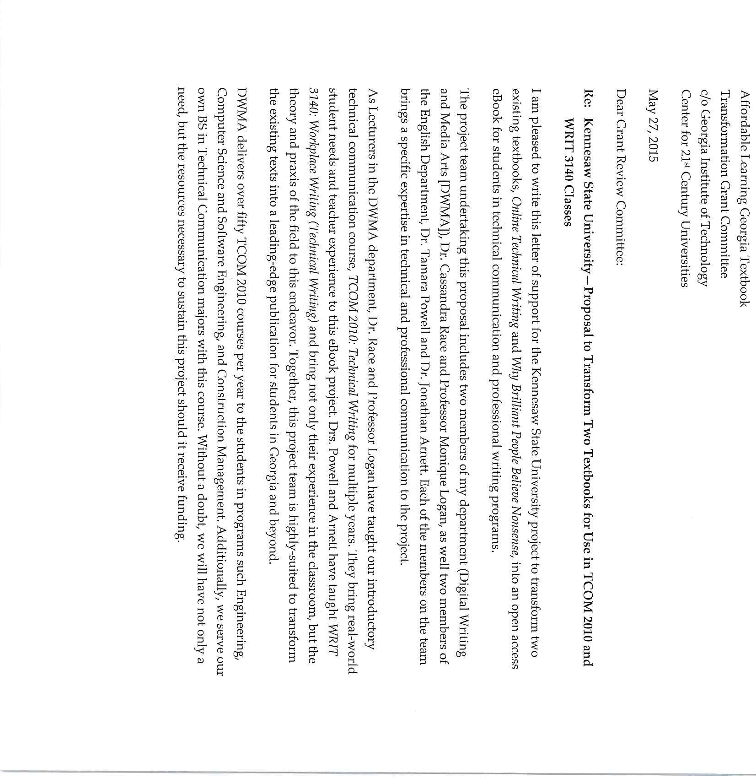

    - of 22

    - of 22

StateU NIVERSITY 0
--'- = = K ennesaw
College of H u m aniti es and Social Science s Department of English

May 27, 2015

To Whom It May Concern:

I write in support of the application for an Affordable Learning Georgia Textbook Transformation grant put forward by Dr. Jonathan Arnett, Dr. Monique Logan, Dr. Cassandra Race, and Dr. Tammy Powell.

If funded, this grant will enable our faculty to create an open-source textbook for WRIT 3140. This open source text will enable the students who take WRIT 3140 to avoid the $115 cost of the textbook that is normally required for the course . Since the open source text will exist on the Internet, it will provide many dynamic features not available in a traditional textbook. Equally important, it will be sustainable indefinitely. Revisions to the text will not require a new edition (and a new expense for students), but rather revisions of the existing online text.

WRIT 3140 is one of the most popular courses we offer in the English Department. The students who take the course are not just English majors. Many of them come from disciplines throughout the university. Should this grant be funded, it will be of enormous benefit to our students. I completely support the grant application.

?Sincer l-y , !
H. William ce, Pli. D. /
Chair and Professor of English

English Building• MD 270I • 440 Bartow Ave. • Kennesaw, GA 30144 Phone: 470-578-6297 • Fax: 470-578-9057 • www.kennesaw.edu

    - of 22

385 Cobb Avenue NW . MD #1701.Kennesaw, GA 30144

May 29, 2015

RE: Letter of Support for Textbook Transformation Grant, No‐Cost‐to‐Students Learning Materials Dear Textbook Transformation Grant Committee:
It is my pleasure to write a letter in support of the proposal for “Free, Open, and Interactive Technical Communication Textbook” being submitted to the Textbook Transformation Grant, No‐Cost‐to Student Learning Materials, by Dr. Tamara Powell, Dr. Jonathan Arnett, Dr. Monique Logan, and Dr. Cassandra Race at Kennesaw State University.

As the Kennesaw State University Affordable Learning Librarian I have worked with Dr. Powell in the past on the KSU video, Affordable Learning Georgia Library Resources: Kennesaw State University. She and her fellow team members are highly qualified to combine and transform the online technical writing textbook called Online Technical Writing by Dr. David McMurrey and two sections of an eBook entitled Why Brilliant People Believe Nonsense by Mr. Steve Miller into a new, online textbook. They are all technology savvy, also. This new book can be used by two academic departments, English and the Digital Writing and Media Arts. The classes using this textbook are usually offered every semester so this would be a huge savings for the students.

Kennesaw State University (KSU) and Southern Polytechnic State University (SPSU) consolidated this past January into the new Kennesaw State University. The SPSU campus is now known as the KSU Marietta Campus. Dr. Powell has asked two Marietta Campus professors to be on her team. The awarding of this grant to this proposal would be a wonderful opportunity for the two campuses to collaborate together.

In conclusion, I fully support the proposal for the “Free, Open, and Interactive Technical Communication Textbook” submitted by Dr. Tamara Powell. Students will benefit by not having to purchase a book.
Two academic departments can use the book. The teaming of the professors from the two new KSU campuses is an opportunity for collaboration and camaraderie. I would be happy to assist Dr. Powell and her associates with any research needs that the library can provide.

Sincerely, Rita Spisak
Librarian, Library Instruction/Outreach (470) 578‐6188

22 of 22

Syllabus

Course Schedule for Summer 2016

Link to Policies

Today's Date | What We're Doing In Class Today | Read This Before Class | What's Due and When

Thursday June 2

Note: Drop/Add deadline is 11:45 p.m. of Monday, June 6
Welcome to WRIT 3140: Workplace Writing
Discuss course policies
Discuss format and conventions of the Email and the Memo
Discuss audience analysis View Audience Analysis PPT
NOTE: Read this Sample Memo file (PDF) after class
Quiz #0: Syllabus Quiz due by 11:59
p.m. of Saturday, June 4
Introductory Memo Exercise due by 11:59 p.m. of
Saturday, June 4

Tuesday June 7
Divide into groups for Audience Analysis Exercise
Discuss basic document design principles
Discuss typographic and document design­related features of MS Word
Begin to work on Document Redesign Exercise
The following sections in Sexy Technical Communication
Introduction: The Nature of Sexy Technical Writing
Audience analysis Task analysis
Page design overview
Headings Lists

Patton ­ Before Creating the Car, Ford Designs the Driver (PDF)
Quiz #1: Audience Analysis due by 11:59
p.m. of Wednesday, June 8
Quiz #2: Document Design due by 11:59
p.m. of Wednesday, June 8

Thursday June 9
Work on Document Redesign Exercise in class
Discuss grammar and style in technical communication
PPT with advice on technical writing style
Practice worksheet for revising style
The following sections in Sexy Technical Communication
Writing process: from audience to rough draft
Articulating technical information
Basic patterns and elements of the sentence
Common grammar, usage, and punctuation problems
Common spelling problems
Power­revision techniques

Keil article (PDF)
Quiz #3: Technical Writing Style due by 11:59 p.m. of
Saturday, June 6
Audience Analysis Exercise due by 11:59 p.m. of
Saturday, June 11
Document Redesign Exercise due by 11:59 p.m. of
Sunday, June 12

Cogan article (PDF)
Ch. 12 of Writing Software Documentation (PDF)
My Blackberry Is Not Working!
Fonts common to MS Word and Windows
Document Design Exercise grading rubric

You may wish to review the videos about how to use MS Word effectively.

Tuesday June 14
Discuss Professional Letter Assignment
Discuss rhetorical principles of writing a technical letter
View and discuss real examples
Student Email Job Hunter Email #1 Job Hunter Email #2

Discuss structure of formal letters
View and discuss business letter examples
Internship Query Partnership Query
The following section in Sexy Technical Communication
Business correspondence and resumes

Knoy ­ Technical Correspondence: What Professionals Need to Learn
Quiz #4: Professional Communication due by 11:59 p.m. of Wednesday, June 15

Thursday June 16
Discuss ethical principles of technical communication
Peer review session for Professional Letter Assignment
Use these questions to help guide your analysis
The following section in Sexy Technical Communication
Ethics

Ethical Principles of the Society for Technical Communication
Bring two printouts of your Professional Letter Assignment. A version on your laptop does not count.
You must bring at least one printout to be present.
You must bring two printouts to get quiz credit.

Professional Letter Assignment due by 11:59 p.m. of
Sunday, June 19

Tuesday June 21

Note: Deadline to withdraw with a grade of "W" is Monday, June 27
Discuss technical definitions and technical descriptions
Practice writing technical descriptions in class (you will receive a participation grade)
Lecture notes on Technical Definitions
Lecture notes on Technical Descriptions
The following sections in

Discuss Instructions Assignment
View and discuss PPT on principles of writing instructions
Sexy Technical Communication
Information structures
Instructions Special notices

Thursday June 23

Note: Deadline to withdraw with a grade of "W" is Monday, June 27
Discuss principles of using graphic elements
View and discuss examples of instructions
wikiHow.com Four Aces Card Trick Creating a PowerPoint Setting a Static IP Address
Annotated sample of instructions
The following sections in Sexy Technical Communication
Tables, graphs, charts
Graphics
Quiz #5: Instructions due by 11:59 p.m. of Saturday, June 25
Quiz #6: Visual Elements due by 11:59 p.m. of
Saturday, June 25
Quiz #7: Instructions Assignment Topic due by 11:59 p.m. of Saturday, June 25

Tuesday June 28
Discuss US and international safety signage
View German safety video
Discuss how to manipulate graphics in MS Word
Engage in activity using MS Word graphics tools
PDF about ISO graphical symbols

Thursday June 30
Work in class on Instructions Assignment
Discuss usability testing Demonstrate a usability test
The following section in Sexy Technical Communication
Usability Testing

Video demonstrating usability test, featuring expert usability tester Steve Krug
link to Flash­ format video: Demo Usability Test in Flash format
link to MOV­ format video: Demo Usability Test in MOV format
Quiz #8: Usability Testing due by 11:59
p.m. of Saturday, June July 2

NOTE: This video is by a professional usability tester; it's long and detailed (the Flash version lacks fully functional controls; don't rewind!), but it's also really good.

Tuesday July 5
Conduct usability testing on your classmates' instructions
NOTE: Bring three things to class
The following section in Sexy Technical Communication
Bring a polished, ready­to­submit printout of your

today:
your completed instructions
all equipment necessary to complete the instructions
a printout of the Usability Worksheet
Oral presentations instructions.
It will count as a quiz grade.

NOTE: If you do not participate fully in the usability test, you will receive a half­letter­grade penalty on the assignment.
Discuss upcoming major assignments:
Individual Project Proposal Exercise
Formal Proposal Assignment
Formal Proposal PPT Assignment

View and discuss Principles of PowerPoint Design PPT
Use the "Lorem Ipsum PPT" to demonstrate features of PPT

Thursday July 7
View PPT about general principles of proposals
Lecture on structure of formal and informal proposals
View and discuss Sample PPTs for Individual Project Proposal Exercise
The following section in Sexy Technical Communication
Proposals

Audiovisual Presentations Made Easy(­ier): Tips for Creating an Effective PowerPoint, Prezi, or Keynote
Past topics for Individual Project Proposals
Grading criteria for Individual Project Proposal
Instructions Assignment due by 11:59 p.m. of
Thursday, July 7
Quiz #9: Principles of Proposals due by 11:59 p.m. of
Sunday, July 10

Tuesday July 12
Hear and evaluate Individual Project Proposals
Prompt attendance is mandatory.
If you are late, you are missing other people's presentations.
You will receive a maximum grade of 50 on the assignment and be counted as absent.
If you do not attend class, you will receive a zero on the Individual Project Proposal assignment.
The following section in Sexy Technical Communication
Collaborative writing
Individual Project Proposal due by 11:59 p.m. of
Tuesday, July 12
Upload completed Peer Evaluation Sheet to the D2L Dropbox by 11:59 p.m. of Tuesday, July 12
NOTE: The Peer Evaluation sheet can only be submitted 1:45 p.m.– 11:59 p.m. of Tuesday, July 12. No late submissions will be accepted.

Quiz #10: Research Techniques due by 11:59 p.m. of

Wednesday, July 13

Thursday July 14
Choose project topics and form work groups
Work on Formal Proposals in class
Lecture on structure of formal and informal reports
Introduce and discuss Progress Report Exercise
Sample Proposal #1 Sample Proposal #2
The following sections in Sexy Technical Communication
Types of technical reports: an overview
Recommendation and feasibility reports
Progress reports
Quiz #11: Principles of Reports due by 11:59 p.m. of
Saturday, July 16
Progress Report due by 11:59 p.m. of Sunday, July 17

Tuesday July 19
Work on Formal Proposals in class
Video on how to insert section breaks in MS Word

Thursday July 21
Hear and evaluate Formal Proposal PPT
Prompt attendance is mandatory.
If you do not attend class, you will receive a zero on the Formal Proposal PPT assignment.
If you do not attend class, your group will receive a one­letter­ grade penalty on the Formal Proposal PPT assignment.
If you are late, you are missing other people's presentations.
Your group will not be penalized, but you will receive a one­letter­ grade penalty on the Formal Proposal PPT assignment, and you will be counted as absent for the day.
Formal Proposal PPT due by 10:59 a.m. (before class) of Thursday, July 21
Upload completed Peer Evaluation of Formal Proposal PPTs to D2L Dropbox by 11:59 p.m. of
Thursday, July 21
NOTE: The Peer Evaluation sheet can only be submitted 1:45–11:59
p.m. of Thursday, July 21. No late submissions will be accepted.

Formal Proposal due by 11:59 p.m. of Friday, July 22

All contents © 2016,
E. Jonathan Arnett, Ph.D.

Final Report

1

Affordable Learning Georgia Textbook Transformation Grants Final Report

Date: May 23, 2017
Grant Number: 137
Institution Name(s): Kennesaw State University
Team Members (Name, Title, Department, Institutions if different, and email address for each):
Dr. Tamara Powell, Director, College of Humanities and Social Sciences Office of Distance Education, Professor of English, Kennesaw State University—Kennesaw Campus, tpowel25@kennesaw.edu
Dr. Jonathan Arnett, Assistant Professor of English, Kennesaw State University—Kennesaw Campus, earnett@kennesaw.edu
Dr. Cassandra Race, Lecturer, Digital Writing and Media Arts, Kennesaw State University— Marietta Campus, crace@kennesaw.edu
Dr. Monique Logan, Lecturer, Digital Writing and Media Arts, Kennesaw State University— Marietta Campus, mlogan15@kennesaw.edu
Ms. Tiffani Reardon, Instructional Designer, College of Humanities and Social Sciences, Kennesaw State University, treardo2@kennesaw.edu
Ms. Megan MacDonald, Instructional Designer, Distance Learning Center, Kennesaw State University, mmacdon3@kennesaw.edu
Mx. James Monroe, Student Worker, College of Humanities and Social Sciences Office of Distance Education, Kennesaw State University, krm0540@students.kennesaw.edu
Mr. Lance Linimon, Closed Captioner, linimon@me.com Project Lead: Dr. Tamara Powell
Course Name(s) and Course Numbers: WRIT 3140: Workplace Writing
TCOM 2110: Technical Communication Semester Project Began: Fall 2015
Semester(s) of Implementation: Summer 2016, Fall 2016
Average Number of Students Per Course Section: Summer: 22 Fall: 23.5 Spring: 25

2

Number of Course Sections Affected by Implementation: Summer 2016: 2; Fall 2016: 11;
Spring 2017: 10
Total Number of Students Affected by Implementation: 496

- Narrative
  - Describe the key outcomes, whether positive, negative, or interesting, of your project.

The transformation experience was exhilarating and inspiring as we achieved our dream of creating a resource for students that was under our control and reflected the way we wanted to teach. It was also challenging—we learned that remixing materials is complicated and time consuming. As human beings, we had human problems get in the way of our project, which caused delays. And that meant we were up against the clock in the last weeks before the pilot.
We found that getting SMEs to create video lectures or schedule filming sessions was harder and more time-consuming than we had anticipated. In spite of being offered $50 honorariums, several of the experts we originally approached backed out at the last minute, and other experts found it difficult to schedule time to record their videos.

Another content-creation problem we encountered was the issue of authorial voice. Six separate authors worked on the book’s chapters and examples, and the final product clearly reflects this division of labor. We somewhat finessed a solution by treating the book as almost an anthology: new chapters bear the name of the group member who created them; transformed chapters that required light editing bear the original authors’ names; and transformed chapters that required extensive editing bear both the editors’ and the original authors’ names.

By far, the most problematic issues that the group members faced appeared while attempting to integrate the McMurrey text’s chapters; rather than being able to edit the existing chapters on a surface level, group members often found themselves rewriting the chapters to solve problems with theory, verbosity, and focus. One example of theoretical problems appeared in a chapter that discussed a technical communicator’s need to “translate” concepts for a document’s audience. In context, the idea of translating ideas from engineering-ese into English makes intuitive sense, but technical communicators prefer to “articulate” concepts so they are appropriate for a target audience [1].

Similarly, the original McMurrey chapters were written in a conversational style, but a major target audience for our OER is engineering and computer science majors, who greatly prefer short, concise documents. Furthermore, the original chapters contained many long paragraphs with multiple sentences, but research indicates that short paragraphs with

3

short, pithy sentences are more readable online—especially on smaller screens—[2], which is how we anticipate our students will access the textbook.

Problems with focus appeared with in-text examples and sample documents that focused almost exclusively on engineering. While many of our students are engineers-in-training, many of our students are computer science majors, and a smaller but significant minority are Integrative Studies majors, whose degrees combine multiple academic areas; examples that exclusively catered to engineers would not benefit either cohort of students. Also, if we wish to expand this OER and extend it to other technical communication or business writing courses, we need to take care not to alienate these other potential readers.

Overall, it was a good experience for us, and a good experience for our students. Thank you to the USG and Affordable Learning Georgia for helping to make this dream of ours a reality.

- J. D. Slack et al. “The technical communicator as author: Meaning, power, authority,” J. Bus. Tech. Comm, vol. 7, no. 1, pp. 12-36, Jan. 1993.

- J. Nielsen and J. Morkes. (1998, Jan. 6). Applying writing guidelines to web pages [Online]. Available: https://www.nngroup.com/articles/applying-writing-guidelines-web-pages/

Quantitative and Qualitative Measures 3a. Overall Measurements
Student Opinion of Materials
Was the overall student opinion about the materials used in the course positive, neutral, or negative?
Total number of students affected in this project: for summer 2016, 36
  - Positive: 95 % of 21 respondents
  - Neutral: 0 % of 21 respondents
  - Negative: 5 % of 21 respondents

4

Student Learning Outcomes and Grades
Was the overall comparative impact on student performance in terms of learning outcomes and grades in the semester(s) of implementation over previous semesters positive, neutral, or negative?

Choose One:
- X--online Positive: Higher performance outcomes measured over previous semester(s)
- Neutral: Same performance outcomes over previous semester(s)
- X—face to face Negative: Lower performance outcomes over previous semester(s)
In the online course, the average grade rose from 74 to 78% (C). In the face to face course, the average grade dropped from 84.38 to 80.42 (B).

Student Drop/Fail/Withdraw (DFW) Rates
Was the overall comparative impact on Drop/Fail/Withdraw (DFW) rates in the semester(s) of implementation over previous semesters positive, neutral, or negative?
Drop/Fail/Withdraw Rate:
For summer 2016
6% of students, out of a total 16 students affected, dropped/failed/withdrew from the face to face course in the first semester of implementation.
16% of students, out of a total 25 students affected, dropped/failed/withdrew from the online course in the first semester of implementation.
Choose One:
- X—face to face Positive: This is a lower percentage of students with D/F/W than previous semester(s)
- Neutral: This is the same percentage of students with D/F/W than previous
semester(s)
- X--online Negative: This is a higher percentage of students with D/F/W than previous semester(s)

3b. Narrative
Here are the statistics from the two pilot courses, one online and one face to face (SUMMER 2016). We also included numbers from the same courses offered the previous summer with publisher materials (SUMMER 2015). Please note, Kennesaw State University and Southern Polytechnic State University consolidated in 2015. This course was originally

5

WRIT 3140: Introduction to Technical Communication in 2015. In 2016, it became WRIT 3140: Workplace Writing. The main student audience shifted from computer science majors to integrative studies majors. For this reason, comparing the data from summer 2015 and summer 2016 has been a bit like comparing apples and oranges.
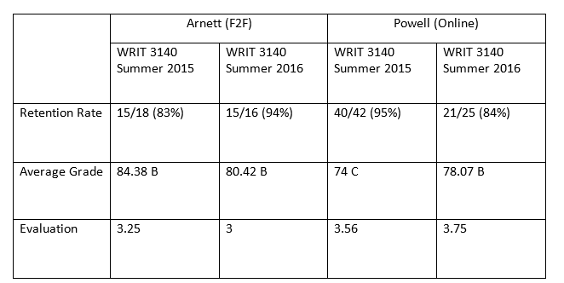

While students had mixed feelings about the textbook, stating in course evaluations that “I did not like the set up of the course textbook. It was just okay.”
and
“Maybe more videos and handouts and a printed book to supplement or in primary use of the content.”
Students were also provided the opportunity to respond to a survey solely about the textbook.
What follows is a summary of the questions and responses from the 21 students who responded, out of 36 total students in the two sections.
Of the respondents, 15 were in the online section, and 5 were in the face to face section, and one declined to answer the question.
Nineteen students said they acquired the textbook without trouble, and two said they had no trouble acquiring it, but they didn’t acquire it because they didn’t want it.
When asked, “Did you feel the organization of the textbook was complementary to the course organization?” 18 answered “yes,” and three answered, “no.”

6

When asked, “Do you feel there were any gaps in the textbook as far as course content goes?” 19 answered “no,” and two answered, “yes.” Students were asked to comment on any gaps observed, but none did.
Students were asked, “Did the textbook for this class help you with coursework?” The responses provided, below.
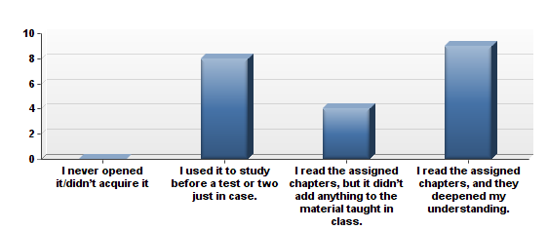

When asked, “Were the example documents provided in the textbook helpful to you as you learned the material?” 8 students answered, “Very helpful,” and 12 students answered, “Somewhat helpful.” No students selected “Not helpful.” One student selected, “Don’t know/couldn’t say.”
As we created the textbook, we were particularly proud of the videos, quizzes, activities, sample documents, and other materials that we created to support learning and engagement in the online textbook. When asked, “Were the supplemental materials in the textbook (videos, quizzes, activities, sample documents) helpful to you as you used the textbook to learn the material?” 12 students responded, “The supplemental materials were somewhat helpful,” and 9 students answered, “The supplemental materials were very helpful.” Three other choices, “There were no supplemental materials in my textbook,” “The supplemental materials were not helpful,” and “The supplemental materials were very helpful” were not selected.

7

When asked, “Think about the supplemental materials in the textbook (videos, quizzes, activities, sample documents). Which of these (videos by experts in the field or professors, practice quizzes on concepts presented in the text, activities to assist you in learning more about the material or exploring the material in depth, sample documents) helped you to learn more about the topic of technical writing/workplace writing?” students answered as follows, showing a preference for the sample documents.

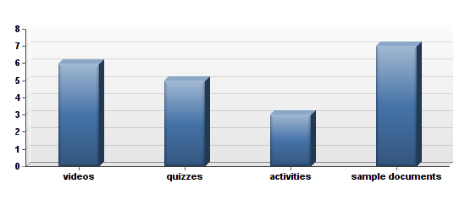
When asked, “Compare this to other textbooks (not including non-textbook assigned reading),” students responded as follows:
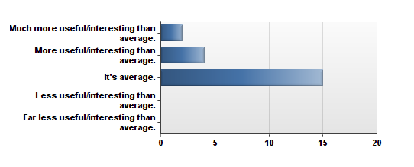

8

When asked, “How useful do you think this textbook will be after class is over?” students responded as follows:
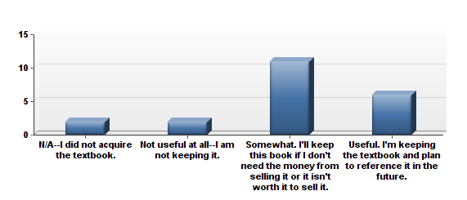

When asked, “How much did cost affect your decision on whether or not to buy and read the book?”
No students answered that they could not afford the open educational resource we had created. This answer changed from 2015 when publisher materials were in use, and 15% of respondents then said “Very much. I could not afford it, so I didn’t buy/read it.”
There were other interesting findings from the survey. Five of the 20 students responding to a question about use of the textbook shared that they printed out at least some of it. Two of the 20 students shared that they sometimes used the screen reader to listen to the ebook instead of read it with their eyes.

9

When asked, “Thinking about the textbook required for the course, which of the following statements do you feel is most accurate about your experience?” The students responded as follows:
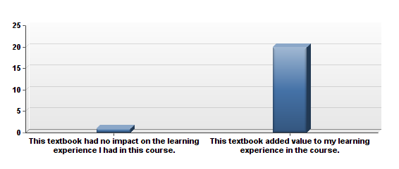

One interesting response emerged from a question regarding how a student decides if he or she acquires the book for a course. One student answered, “I never acquire a textbook, no matter what.” Presumably, even though a free textbook was provided, the student declined to use it.
Students were also asked to provide any additional feedback they wishes (these responses are shared in their entirety under “Quotes,” below.) From the student responses, we realized that perhaps in addition to a video assisting students in navigating the D2L site, we should also create a video to assist them in navigating the online textbook. Also, we want to continue to add examples, videos, activities, and sample documents to the textbook as we continue to update it each year.
In comparing the survey data from summer 2015, when publisher textbooks were used, to the survey data from 2016 when the OER was used, some interesting findings presented themselves.
In 2015, 2/26 students said that they were unable to afford the textbook, vs. 0/21 in 2016.
When asked, “Did you feel the organization of the textbook was complementary to the course organization,” 95% said “yes” in 2015. 85.71% said “yes” in 2016, indicating that the new courses need to be looked at carefully to ensure they are aligned with the textbook when appropriate.
When asked, “Do you feel there were any gaps in the textbook as far as course content goes,” 0% said yes in 2015 vs. 9.52% who answered “yes” in 2016. Students were asked to supply details in a space below the question, but none did. However, in the course

10

evaluations, one student requested that instructions and standard operating procedures be added to the course, and the instructors have discussed adding those materials as soon as possible to WRIT 3140.
When asked, “Did the textbook for this class help you with coursework,” in 2015, 19.25% said they never opened it vs. 0% who responded that way in 2016. In 2015, 50% of the students said they read the assigned chapters and it deepened their understanding vs.
42.86% who answered the same way in 2016.
When asked, “Were the supplemental materials in the textbook (videos, quizzes, activities, sample documents) helpful to you as you used the textbook to learn the material,” 26.92% said “yes” in 2015 vs. 42.86% in 2016. And it’s true, we are very proud of the supplementary materials the subject matter experts and instructional designers placed in the course.
In 2016, 80% of students said they acquired the book without stress, compared to 65.38% in 2015.
Finally, when asked to choose between two statements, 1) This textbook had no impact on the learning experience I had in this course vs. 2) This textbook added value to my learning experience in the course, 73.08% selected #2 in 2015 compared to 95.24% who selected #2 in 2016. Both surveys are included in this final report.

2. Quotes
At the end of the survey, student were asked for any feedback they wished to share. Here are the 12 responses that were provided.

This textbook was easy to understand and move through the course. The only thing I did not
like was there were not very many visuals and examples.
it was so helpful
I love that the text book was given to the course instead of having to purchase the book. The
material was useful but was difficult to see all of it because of the way it was organized.
The textbook was helpful, but not as helpful as other textbooks. I wish it was better
description and examples provided for each section.
This class was very interesting especially since it is my last semester. [The professor] is a great instructor and cares about [the] students. However, it took some time getting use to the course material and the modules. The information I grasp I will continue to apply it in my
everyday life.
The textbook was helpful in guiding me through the assignments. The activities were the most helpful out of all the supplemental materials for the class.
I felt that this book was perfectly integrated with the course material and assignments. It definitely helped me on all assignments and quizzes as well as have me a better
understanding of the material we covered.

11

I am glad I did not have to pay for the book because it allowed me to save money. I found the
book easy to access. The book works well with the course.
I feel this course is full of useful information regarding technical/workplace writing. I am not 100% sure if it is the course material or the layout of the online book but at times it got confusing to follow. It did not always flow very well, but that could be do to the material at
hand and not necessarily because of the book.
I liked how the book was provided to the class. It was also very helpful to have the extra
clarification in understandable terms so that I could understand all the concepts.
having the online readings allowed it useful and affordable to educate and increase my
knowledge for my class.
The survey that this online course just had to take wasn't fully relevant to us considering that we didn't have to buy the textbook at all because it was provided to us in our modules. This made answering some of these questions a bit difficult. The book is well written and very informative on the topics at hand. For me personally if each module could be set up where there is one page rather than multiple pages it would be less overwhelming for each week.
But other than that, the textbook is very well laid out and written.

Additional data:
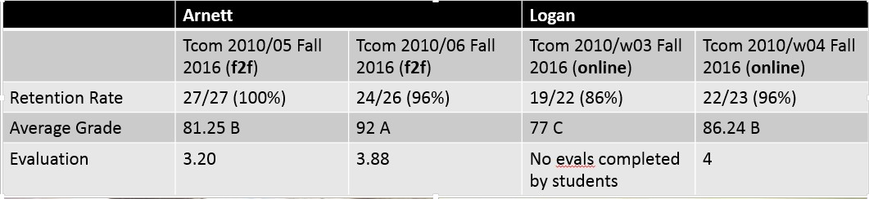

12

Sustainability Plan
The materials are freely available to anyone on the internet. Each year we will discuss revisions. We also plan to add videos and sample documents to enhance the usefulness of the offerings. We will meet and discuss revisions each year. In the survey, some students indicated that they did not feel the course organization was complementary to the textbook. We will examine the course revisions to ensure that they are aligned more closely with the textbook when appropriate. Also, as noted in the narrative, for WRIT 3140, the student audience changed from information science majors in 2015 to integrative studies (leadership studies) majors in 2016. (For the TCOM 2010 offerings, the audience will remain engineering majors and information science majors.) In 2016, 2 students indicated that they felt there were gaps in the textbook as far as course content was concerned. While these two respondents declined to provide details, in the course evaluations, students requested that writing instructions and standard operating procedures be added to the course. This information is included in the new textbook but was not assigned in the 2016 online course. From reviewing this student feedback, it seems that writing instructions and standard operating procedures readings and assignments need to be added to the 2017 online WRIT 3140 course.

Future Plans
From Jonathan Arnett:
I'd like to continue revising the book, as I'm not thrilled with its current state. I have asked Tiffani Reardon to install analytics and track how students are using/not using the book; a few presentations and at least one publication (likely IEEE) could come out of that, for sure.

From Cassandra Race:
I've come to a more powerful recognition of just how important it is to tailor our materials to our student population, and I've learned that I am really, really picky about what I use! I also like creating my own materials and lessons, and just using the text as a reference or foundation. That allows me the flexibility to have a text as support while tailoring instruction to needs of the students, for example the engineering students writing the proposals for capstones and so forth.

From Monique Logan:
Thus far, I along with members of this book project as well as those of my department plan to present Sexy Technical Communication at the ProComm 2016 conference in Austin, TX on October 3-5, 2016.

From Tamara Powell
I have been asked to create an African American literature course, and after this project, I have designed the new course to use OERs completely.

13

Description of Photograph
Left to right, Dr. Cassandra Race, Subject Matter Expert; Dr. Monique Logan, Subject Matter Expert; Dr. Jonathan Arnett, Subject Matter Expert, Ms. Tiffani Reardon, Instructional Designer; Dr. Tamara Powell, Team Lead and Subject Matter Expert.

